Assignment # 3


Submitted by:
Submitted by:

Name | Registration No.
Muhammad Abdullah | FA24-BSE-042

Submitted to: Mam Rubina
Course: DBMS
Dated: May 21, 2026

DEPARTMENT OF COMPUTER SCIENCE
COMSATS UNIVERSITY ISLAMABAD,
ISLAMABAD CAMPUS

Problem 1: COMSATS University Islamabad Academic System [2 Marks]
This problem involves modeling the COMSATS academic structure, including persons (faculty and administrative staff), departments, postings, and roles using an Enhanced Entity-Relationship (EER) diagram and relational schema up to 3NF.

EER Diagram Description

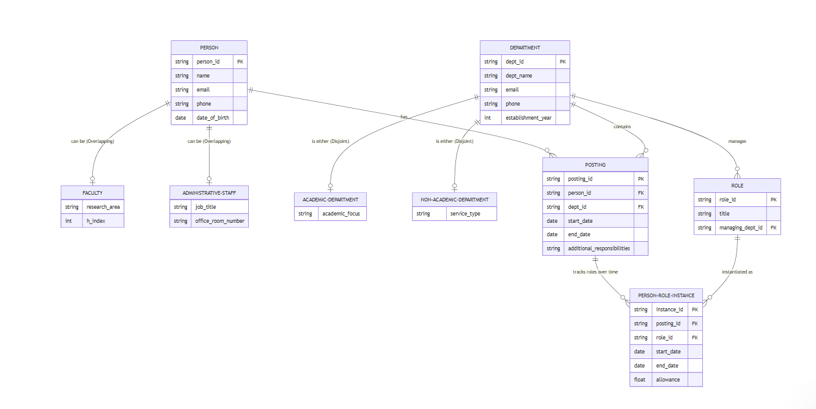

1.2 Relational Schema
After transforming the EER diagram:
Person(person_id PK, name, email, phone, date_of_birth)
Faculty(person_id FK->Person PK, research_area, h_index)
AdministrativeStaff(person_id FK->Person PK, job_title, office_room_number)
Department(dept_id PK, dept_name, email, phone, establishment_year)
AcademicDepartment(dept_id FK->Department PK, academic_focus)
NonAcademicDepartment(dept_id FK->Department PK, service_type)
Posting(posting_id PK, person_id FK->Person, dept_id FK->Department, start_date, end_date, additional_responsibilities)
Role(role_id PK, title, managing_dept_id FK->Department)
PersonRoleInstance(instance_id PK, posting_id FK->Posting, role_id FK->Role, start_date, end_date, allowance)

1.3 Normalization to 3NF
First Normal Form (1NF)
All attributes are atomic (no multi-valued or composite attributes stored directly). All tables have a primary key. Achieved.
Second Normal Form (2NF)
No partial dependencies exist because all non-composite primary keys are used. In Posting, both person_id and dept_id together are meaningful, but posting_id is surrogate PK. PersonRoleInstance uses instance_id as surrogate PK. All non-key attributes depend fully on the full PK. Achieved.
Third Normal Form (3NF)
No transitive dependencies:
- In Faculty, research_area and h_index depend only on person_id (PK), not on each other transitively.
- In Posting, start_date, end_date, and responsibilities all depend directly on posting_id.
- In PersonRoleInstance, allowance depends directly on instance_id (the specific occurrence of a role), not transitively on role_id. If allowance were determined only by the role, it would move to the Role table.
- All tables satisfy 3NF.

1.4 Final 3NF Schema Tables
Table Name | Primary Key | Foreign Keys | Other Attributes
Person | person_id | — | name, email, phone, dob
Faculty | person_id | person_id -> Person | research_area, h_index
AdministrativeStaff | person_id | person_id -> Person | job_title, office_room_no
Department | dept_id | — | dept_name, email, phone, estab_year
AcademicDepartment | dept_id | dept_id -> Department | academic_focus
NonAcademicDepartment | dept_id | dept_id -> Department | service_type
Posting | posting_id | person_id->Person, dept_id->Dept | start_date, end_date, responsibilities
Role | role_id | managing_dept_id -> Department | title
PersonRoleInstance | instance_id | posting_id->Posting, role_id->Role | start_date, end_date, allowance

Problem 2: Database for Law Firm [2 Marks]
This problem models a law firm's case management system, including cases, plaintiffs, defendants, and legal entities (persons or organizations).

2.1 EER Diagram Description

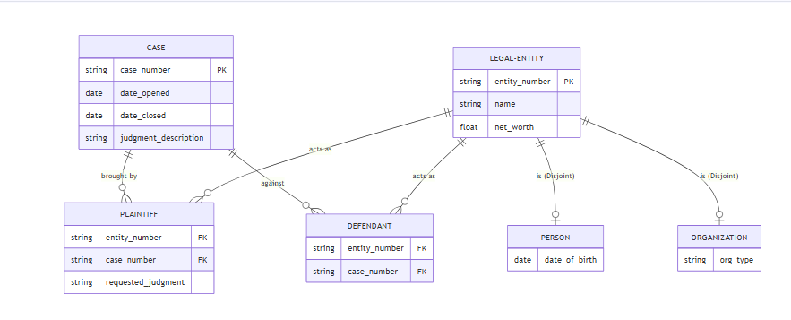

2.2 Relational Schema
LegalEntity(entity_number PK, name, net_worth, entity_type CHECK('Person','Organization'))
Person(entity_number FK->LegalEntity PK, date_of_birth)
Organization(entity_number FK->LegalEntity PK, org_type)
Case(case_number PK, date_opened, date_closed, judgment_description)
Plaintiff(entity_number FK->LegalEntity, case_number FK->Case, requested_judgment, PRIMARY KEY(entity_number, case_number))
Defendant(entity_number FK->LegalEntity, case_number FK->Case, PRIMARY KEY(entity_number, case_number))

2.3 Normalization to 3NF
1NF
All attributes are atomic; every table has a defined primary key. Achieved.
2NF
Plaintiff table has composite PK (entity_number, case_number). The attribute requested_judgment is a characteristic of the plaintiff's role in that specific case — it depends on the full composite key, not a partial key. Achieved.
3NF
No transitive functional dependencies:
- In Case: date_opened, date_closed, judgment_description all depend directly on case_number.
- In LegalEntity: name and net_worth depend on entity_number; entity_type is stored but no attribute depends on entity_type transitively.
- In Plaintiff: requested_judgment depends on (entity_number, case_number) — no transitivity.
- All tables are in 3NF.

2.4 Final 3NF Schema Tables
Table Name | Primary Key | Foreign Keys | Other Attributes
LegalEntity | entity_number | — | name, net_worth, entity_type
Person | entity_number | entity_number -> LegalEntity | date_of_birth
Organization | entity_number | entity_number -> LegalEntity | org_type
Case | case_number | — | date_opened, date_closed, judgment_description
Plaintiff | (entity_number, case_number) | entity_number->LegalEntity, case_number->Case | requested_judgment
Defendant | (entity_number, case_number) | entity_number->LegalEntity, case_number->Case | —

Problem 3: Library Management System for Rare Books [2 Marks]
This problem models a specialized library that manages rare, antique, and special edition books along with borrowers of different membership tiers and exhibitions.

3.1 EER Diagram Description

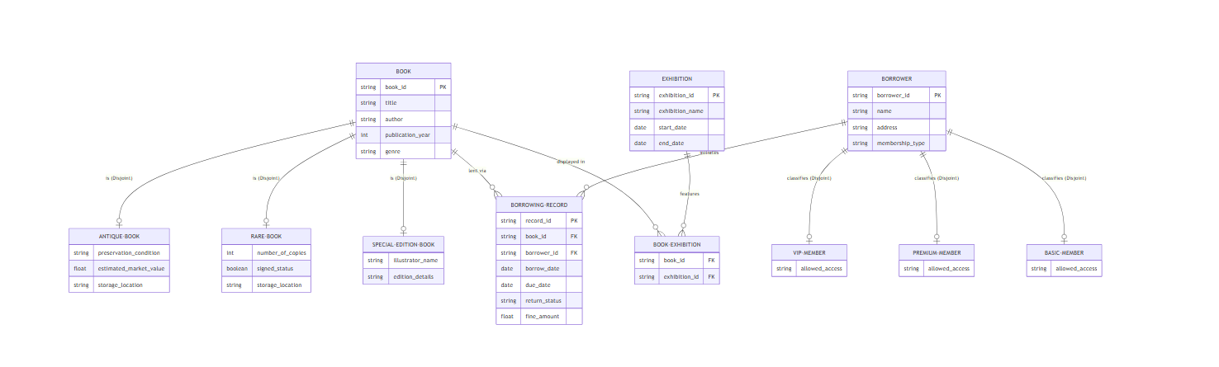

3.2 Relational Schema
Book(book_id PK, title, author, publication_year, genre, book_type CHECK('Antique','Rare','SpecialEdition'))
AntiqueBook(book_id FK->Book PK, preservation_condition, estimated_market_value)
RareBook(book_id FK->Book PK, number_of_copies, signed_status)
SpecialEditionBook(book_id FK->Book PK, illustrator_name, edition_details)
Borrower(borrower_id PK, name, address, membership_type CHECK('Basic','Premium','VIP'))
BorrowingRecord(record_id PK, book_id FK->Book, borrower_id FK->Borrower, borrow_date, due_date, return_status, fine_amount)
Exhibition(exhibition_id PK, exhibition_name, start_date, end_date)
BookExhibition(book_id FK->Book, exhibition_id FK->Exhibition, PRIMARY KEY(book_id, exhibition_id))

3.3 Normalization to 3NF
1NF
All fields atomic. PKs defined. fine_amount is stored as NULL when return_status = 'Returned'. Achieved.
2NF
BorrowingRecord uses surrogate PK record_id, so no partial dependency. BookExhibition has composite PK with no non-key attributes. Achieved.
3NF
Checking for transitive dependencies:
- In BorrowingRecord: fine_amount depends on return_status ('Overdue') — this is a conditional attribute but not a transitive dependency since fine_amount is determined by the specific record (record_id), not via a functional chain through another non-key attribute. If fine policy were standardized per membership tier, we might need a separate FinePolicy table, but as stated fine_amount is per record.
- In Borrower: membership_type does not determine name or address — no transitivity. If we needed to store membership-tier features separately, we could, but that is not required here.
- All tables satisfy 3NF.

3.4 Final 3NF Schema Tables
Table Name | Primary Key | Foreign Keys | Other Attributes
Book | book_id | — | title, author, pub_year, genre, book_type
AntiqueBook | book_id | book_id -> Book | preservation_condition, market_value
RareBook | book_id | book_id -> Book | num_copies, signed_status
SpecialEditionBook | book_id | book_id -> Book | illustrator_name, edition_details
Borrower | borrower_id | — | name, address, membership_type
BorrowingRecord | record_id | book_id->Book, borrower_id->Borrower | borrow_date, due_date, return_status, fine_amount
Exhibition | exhibition_id | — | exhibition_name, start_date, end_date
BookExhibition | (book_id, exhibition_id) | book_id->Book, exhibition_id->Exhibition | —

Problem 4: Faculty Database [2 Marks]
This problem models a university research environment including professors, graduate students, projects, departments, and various supervisory/advisory relationships.

4.1 EER Diagram Description

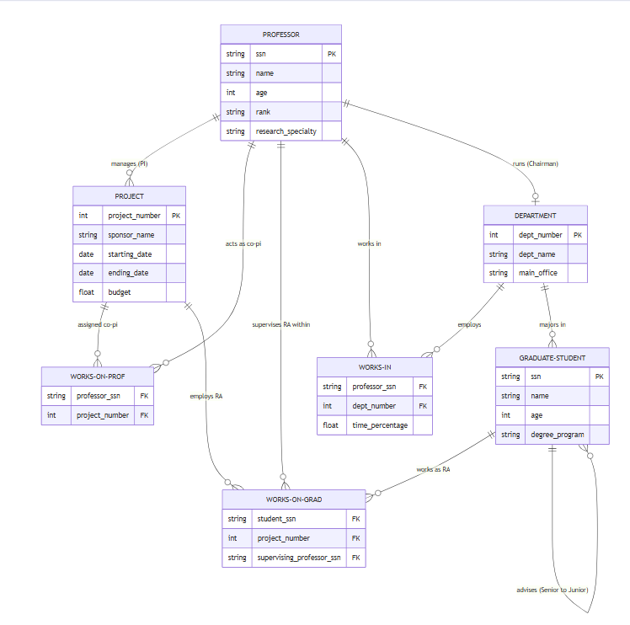

4.2 Relational Schema
Professor(ssn PK, name, age, rank, research_specialty)
GraduateStudent(ssn PK, name, age, degree_program, major_dept_number FK->Department, advisor_ssn FK->GraduateStudent)
Project(project_number PK, sponsor_name, starting_date, ending_date, budget, pi_ssn FK->Professor)
Department(dept_number PK, dept_name, main_office, chairman_ssn FK->Professor)
ProfProject(prof_ssn FK->Professor, project_number FK->Project, PRIMARY KEY(prof_ssn, project_number))
GradProject(student_ssn FK->GraduateStudent, project_number FK->Project, supervisor_ssn FK->Professor, PRIMARY KEY(student_ssn, project_number))
ProfDept(prof_ssn FK->Professor, dept_number FK->Department, time_percentage, PRIMARY KEY(prof_ssn, dept_number))

4.3 Normalization to 3NF
1NF
All attributes atomic. All tables have defined primary keys. Achieved.
2NF
Checking composite PKs for partial dependencies:
- ProfProject: PK is (prof_ssn, project_number) — no non-key attributes, so no partial dependency.
- GradProject: PK is (student_ssn, project_number). The attribute supervisor_ssn depends on the full composite key (which professor supervises a specific student on a specific project), not on student alone or project alone. Achieved.
- ProfDept: PK is (prof_ssn, dept_number). Attribute time_percentage depends on the combination. Achieved.
3NF
Checking transitive dependencies:
- In Professor: rank, research_specialty, name, age all depend directly on ssn. No transitivity.
- In GraduateStudent: major_dept_number and advisor_ssn are FKs — they represent relationships, not transitive FDs.
- In Project: pi_ssn (FK to Professor) — no attribute of Professor is stored here (no transitivity). Budget, dates, sponsor all depend on project_number.
- In Department: chairman_ssn (FK to Professor) — no transitivity.
- All tables are in 3NF.

4.4 Final 3NF Schema Tables
Table Name | Primary Key | Foreign Keys | Other Attributes
Professor | ssn | — | name, age, rank, research_specialty
GraduateStudent | ssn | major_dept_number->Dept, advisor_ssn->GradStudent | name, age, degree_program
Project | project_number | pi_ssn -> Professor | sponsor_name, start_date, end_date, budget
Department | dept_number | chairman_ssn -> Professor | dept_name, main_office
ProfProject | (prof_ssn, project_number) | prof_ssn->Prof, project_number->Project | —
GradProject | (student_ssn, project_number) | student_ssn->Grad, project_number->Project, supervisor_ssn->Professor | —
ProfDept | (prof_ssn, dept_number) | prof_ssn->Prof, dept_number->Dept | time_percentage

Problem 5: Scheduling Classes Database [2 Marks]
This problem models a class scheduling system for an international school of technology, covering rooms, media types, computer types, instructors, courses, sections, timeslots, and semester schedules.

5.1 EER Diagram Description

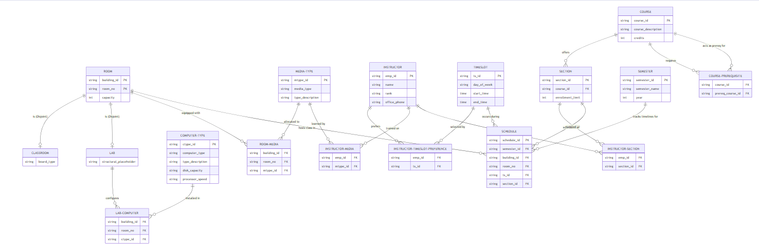

5.2 Relational Schema
Room(building_id, room_no, capacity, room_type CHECK('Lab','Classroom'), PRIMARY KEY(building_id, room_no))
Classroom(building_id, room_no, board_type, PRIMARY KEY(building_id, room_no), FK->(building_id, room_no)->Room)
Lab(building_id, room_no, PRIMARY KEY(building_id, room_no), FK->(building_id, room_no)->Room)
MediaType(mtype_id PK, media_type, type_description)
ComputerType(ctype_id PK, computer_type, type_description, disk_capacity, processor_speed)
Instructor(emp_id PK, name, rank, office_phone)
Timeslot(ts_id PK, day_of_week, start_time, end_time)
Course(course_id PK, course_description, credits)
CoursePrerequisite(course_id FK->Course, prereq_id FK->Course, PRIMARY KEY(course_id, prereq_id))
Section(section_id PK, course_id FK->Course, enrollment_limit)
Semester(semester_id PK, semester_name, year)
Schedule(schedule_id PK, semester_id FK->Semester, building_id, room_no, ts_id FK->Timeslot, section_id FK->Section, FK(building_id, room_no)->Room, UNIQUE(semester_id, building_id, room_no, ts_id))
InstructorSection(emp_id FK->Instructor, section_id FK->Section, PRIMARY KEY(emp_id, section_id))
InstructorTimeslotPref(emp_id FK->Instructor, ts_id FK->Timeslot, PRIMARY KEY(emp_id, ts_id))
RoomMedia(building_id, room_no, mtype_id FK->MediaType, PRIMARY KEY(building_id, room_no, mtype_id), FK(building_id, room_no)->Room)
InstructorMedia(emp_id FK->Instructor, mtype_id FK->MediaType, PRIMARY KEY(emp_id, mtype_id))
LabComputer(building_id, room_no, ctype_id FK->ComputerType, PRIMARY KEY(building_id, room_no, ctype_id), FK(building_id, room_no)->Lab)

5.3 Normalization to 3NF
1NF
All attributes are atomic. Room's composite PK (building_id, room_no) is valid. All M:N relationships resolved into associative tables. Achieved.
2NF
Checking all composite PKs:
- Schedule: schedule_id is surrogate PK — no partial dependencies on composite FKs.
- CoursePrerequisite, InstructorSection, etc.: no non-key attributes, so trivially in 2NF.
- RoomMedia, LabComputer: no non-key attributes.
- Achieved.
3NF
Checking transitive dependencies:
- In Room: capacity depends on (building_id, room_no). room_type does not cause any attribute to depend on it transitively (Lab/Classroom subtype data is in separate tables).
- In Classroom: board_type depends on the room PK — no transitivity.
- In ComputerType: all attributes depend on ctype_id. processor_speed and disk_capacity describe the type, not anything else.
- In Schedule: section_id FK points to Section — we do not replicate Section attributes here (no transitivity).
- All tables are in 3NF.

5.4 Final 3NF Schema Tables
Table Name | Primary Key | Foreign Keys | Other Attributes
Room | (building_id, room_no) | — | capacity, room_type
Classroom | (building_id, room_no) | (building_id, room_no) -> Room | board_type
Lab | (building_id, room_no) | (building_id, room_no) -> Room | —
MediaType | mtype_id | — | media_type, type_description
ComputerType | ctype_id | — | computer_type, type_desc, disk_cap, proc_speed
Instructor | emp_id | — | name, rank, office_phone
Timeslot | ts_id | — | day_of_week, start_time, end_time
Course | course_id | — | course_description, credits
CoursePrerequisite | (course_id, prereq_id) | course_id->Course, prereq_id->Course | —
Section | section_id | course_id -> Course | enrollment_limit
Semester | semester_id | — | semester_name, year
Schedule | schedule_id | semester_id, (bldg,room)->Room, ts_id, section_id | UNIQUE(sem, room, ts)
InstructorSection | (emp_id, section_id) | emp_id->Instructor, section_id->Section | —
InstructorTimeslotPref | (emp_id, ts_id) | emp_id->Instructor, ts_id->Timeslot | —
RoomMedia | (bldg, room_no, mtype_id) | (bldg,room)->Room, mtype_id->MediaType | —
InstructorMedia | (emp_id, mtype_id) | emp_id->Instructor, mtype_id->MediaType | —
LabComputer | (bldg, room_no, ctype_id) | (bldg,room)->Lab, ctype_id->ComputerType | —

